
SUBJECT : software construction and development LAB
ASSIGNMENT NO : 4
NAME : MOIN UD DIN
ID : CU-4365-2023
SECTION:D
DEPARTMENT: SOFTWARE ENGINEERING

1. Write a function that takes a price and tax percentage and returns the final price after
tax.

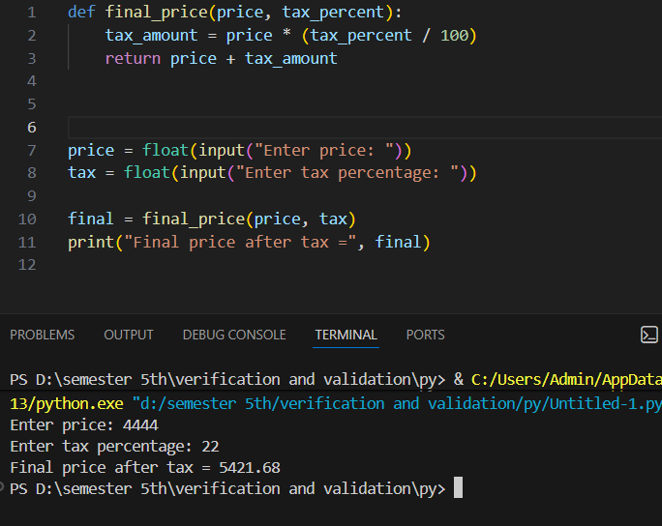

2. Make a function that accepts a number and returns its factorial.

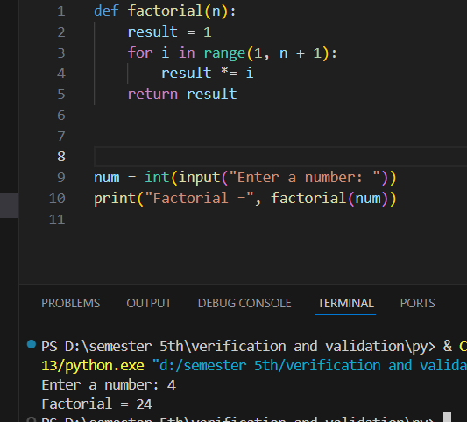
3. Write a function that accepts a temperature in Celsius and returns
&quot;Cold&quot; if temp &lt; 10
&quot;Warm&quot; if 10–25
&quot;Hot&quot; if &gt; 25
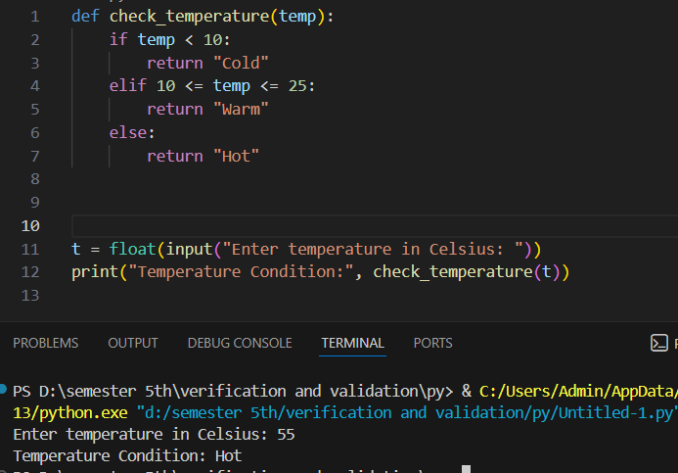

4. Create a function that takes two numbers and returns
The sum
The difference
The product

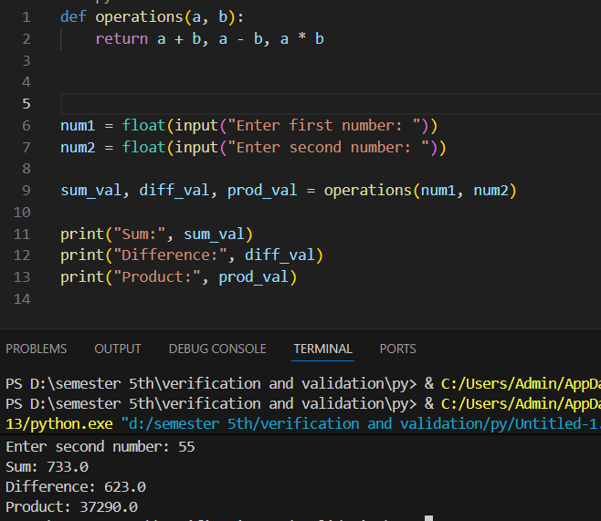

5. Pass the list to the function and sum all the values of the list.
